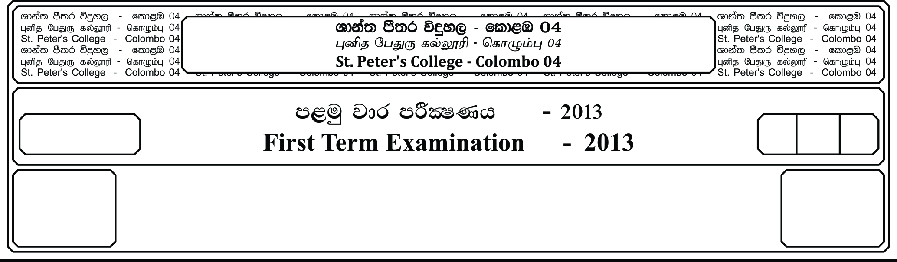

meh 2.

2 Hours.

II

**f;jk jdr mÍCIKh - 2021**

**Third Term Examination - 2021**

E

jHdmdr wOHkh - **II**

**Business Studies - II**

13 fY%aKsh

GRADE 13

**Instructions;**

↓ **Select at least 2 questions each from one section & answer 5 questions in total.**

**Section - A**

01. i. a). What’s the human need fulfilled by a government hospital & what are the ways this need is being fulfilled?

b). Do you consider the above establishment as a business? Testify your answer

c). Business objectives are important for the sustainability of a business. Confirm this statement with the help of two points.

ii. a). “Use of coins & notes enabled to overcome drawbacks of the mediums used for exchange prior to it” State 2 points to confirm this statement.

b). “Industrial revolution is an important mile stone in the development of business”. State 2 points to confirm this statement.

c). “According to the nature of business there can be differences in the application of business functions.” State 2 examples to confirm this statement.

d). “Business is a process.” Do you agree? Confirm this statement.

iii. a). “While a business need stakeholders, they too need business” confirm this statement using 2 examples.

b). Discuss the importance of following concepts for the business field.

1. Commerce -

2. Specialization -

iv. a). Name an opportunity & a threat which could occur from the task environment for a restaurant & explain how this business should handle it.

b). “Business strengths can be used to minimize drawbacks of weaknesses from the internal

environment” Taking 2 examples confirm this statement.

v. a). State a negative impact of the following trends to business stakeholders & state one point each how social responsibilities would contribute to overcome them.

1. Heavy competition -

2. E - business -

b). State how business could contribute for economic & environmental sustainability

02. i. a). State the ways of government intervention on an apparel exporting business

b). What’s expected from internal price stability & external price stability

c). According to the classification of state taxes what’s the base used to charge direct & indirect taxes, briefly explain with an example.

ii. a). How could the fiscal policy be used to protect the local businessman?

b). How does the central bank of Sri Lanka impose selective credit restrictions?

c). Ensuring consumer protection is important for both businessman & consumers. State 2 points each, for both parties

iii. a). “Incorpated companies are more advantageous than partnerships”. State point in favour of this statement & against this statement

b). Compare registration of cooperatives with registration of partnerships.

iv. a). Give examples to clarify vertical & conglomerate combination

b). “The Franchise system of doing business has certain limitations”. What are these limitations.

c). “State business organizations are not essential to the Sri Lankan economy.” What’s your view about this statement.

v. a). What factors differentiates cotes entrepreneurship from business?

b). “ There is a positive relationship between entrepreneurship & economic development”. Confirm this statement.

c). Categorize factors which cause failure of small enterprises as controllable factors & uncontroble factors.

03. i. a). Discuss the contribution of the state to promote small & medium enterprises

b). In which way Global entrepreneurship & Entrepreneurship will be important for business.

ii. a). Discuss the contribution of licensed specialized banks to support businessmen.

b). “Cooperative rural banks are important to support the cooperative movement.” Confirm this statement.

c). “Certain investors prefer to invest in unit trust, rather than directly investing in the share market”. state points to support this statement.

iii. a). State the basic objectives of the central bank of Sri Lanka & the importance to the economy of those objectives.

b). “Automated banking services will have it’s limitation? What are they?

c). “Order cheques are safer than bearer cheque”. Do you agree? Comment your views

iv. a). “Credit cards are widely accepted by traders due to the benefits out of them, but there are certain drawbacks of them to the traders too” state points to confirm this statement.

b). “Insurance will support business to fulfill corporate social responsibilities.” confirm this statement with the help of two examples.

v. a). Differentiate life insurance & general insurance policies in respect of insurance principles such as contribution & insurable interest.

b). “Reinsurance is useful to the insurer, not to the insured”. Do you agree? Comment your views

c). In which way life insurance policies are more beneficial than general insurance policies?

04. i. a). As a businessman in foreign trade, to decide whether to select between air or shipping transportation, what factors will be considered? Briefly explain 2 points.

b). In which way the expressways have contributed for business development.

c). As a businessman providing a cab service to customers, What factors should be considered to provide a better services to them.

ii. a). What factors are considered when strong goods in the warehouse.

b). What are the two ways pallet flow can be fixed? Briefly explain

c). For what purposes logistic services are required?

iii. a). “State the role of internal communication to increase the productivity of a business firm.

b). At what kind of instances signs & symbols might be less effective as a communication medium.

c). What are the noises of communication you could might observe in a school & state solution to overcome them.

iv. a). Sunimal is a lecturer of a privet university. In order to make his lecturers more interesting & effective to his students, What factors should be focussed by him.

b). What are the 2 main ways of Non store retailing.

c). How does the wholesaler controls the market price.

d). State the role of the following agents.

1. Factors -

2. Delcrader Agent -

v. a). How does foreign trade contribute for economic development?

b). Name documents which should be prepared by the exporter & importer.

c). What are the restrictions of e - commerce.

**II – Part**

05. i. a). Explain 02 analysis which will be done in the planning process.

b). How does management contribute to accomplish individual & organization aims & objectives? Write 2 points for each.

ii. a). Why is the role of a figure head, Leader & Liaison considered as interpersonal role of a manager.

b). What’s the role of a middle level manager.

c). What are the features of business objectives.

iii. a). What factors should be considered when determining the best alternative as a solution for a problem.

b). What’s meant by a project.

c). Differentiate chain of command & unity of command.

iv. a). According to behavioral pattern of leaders, classify them & state the features of these leadership styles.

b). Why is the control process important in management?

v. a). What’s the basic role of operations management?

b). What’s the role of production engineering.

c). At what type of instances Job production & flow production will be suitable to be used.

d). Name some cost which should be borne by a furniture manufacturing firm, even any production isn’t done

06. i. a). What’s the ideal layout plan for a furniture manufacturing firm? Explain how it would be implemented

b). In certain a manufacturing firm to produce 600 units, the total cost borne was Rs. 6000 while they will earn Rs. 6000 by selling these Units. To produce 600 units variable cost incurred is Rs. 3000

1. Find the variable cost per unit & the fixed cost

2. To earn a profit of Rs. 20,000 how many units should be sold.

ii. a). What factors are considered by a manufacturing firm when purchasing materials.

b). “Expenses on Research & development is wastage of resources.” Do you agree? Comment your views.

iii. a). What are the consequences of over stokes & under stocks

b). What are quality circles

c). What’s meant by system of determining stock levels as an inventory control system.

d). What’s Economic order quantity.

iv. a). What are the tasks or activities relevant to the data processing process?

b). What’s the role of a productive information system.

v. a). What’s meant business Intelligence systems

b). What are the uses of transaction processing systems for the Human resource department & Finance department.

c). In which way Information management technology is useful to business organizations?

07. i. a). For business manufacturing & Selling equipment, what are the most suitable promotion strategies & distribution channels that can be used?

b). What are the special features of Events & experiences as a promotion strategy?

c). In which way the primary package is important for a product.

ii. a). Propose a suitable brand to introduce a new eco-friendly electric bulb to the market & state reasons for your choice.

b). At which stage of the product life cycle smart televisions are going through? Give reasons for your answer

c). Explain Augmented product taking a chair as an example.

iii. a). What’s the relationship between market positioning & the target market.

b). What the relationship between value & satisfaction.

iv. a). What’s the importance of the S & P SL 20 index?

b). What are the results of capitalization of reserves?

c). The stated capital of public limited Rs. 200 million & 30% of shares are issued to the public. What the suitable board to list this company in the Colombo stoke exchange? What’s the active time period required to be listed in this board?

d). Give examples for capital investment decisions.

v. a). Why are treasury bills considered as a productive investment source?

b). What are the feature of treasury bonds?

c). What’s meant by financial infrastructure? Given examples?

d). What are the main tasks of Finance management?

08. i. a). “Every manager is a human resource manager” Evaluate this statement.

b). “Human resource manager exercise their authority vertically as well as horizontally” Evaluate this statement.

ii. a). Explain the relationship between job analysis, job description & job specification.

b). What are the strategies which can be used when there is a surplus of labour & when there is a scarcity of labour.

iii. a). In which ways external recruitment will be better than internal recruitment

b). What’s intended to be assessed through a background investigation of a job candidate

c). What’s the importance of an appointment letter

d). “Performance appraisal can be beneficial as well as disadvantageous to an employee”

Testify this statement.

iv. a). Compare training & development

b). What are the features of employee promotions

c). What are the reasons which cause employee grievances in relation to Human resource management policies, procedures & strategies

d). What action can be taken by employers to prevent industrial action of employees

v. a). What details are given under proposed marketing strategies in a marketing plan?

b). Why is the executive summary important in a business plan

c). What’s meant by a project summary

d). What are the criterias which can be used analyze non-financial reports of a firm?